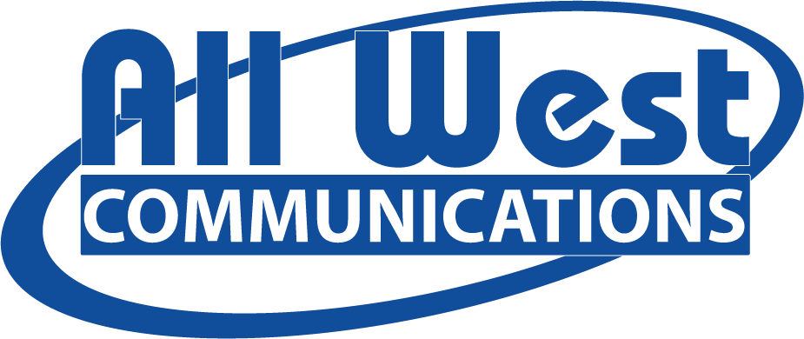

JOIN OUR TEAM: WE’RE GROWING!
All West Communications is a rapidly expanding mid-sized telecommunications company providing internet, video, and phone services. We believe that every connection counts and that people should have access to quality services and communication, no matter where they live. We use our expertise to create opportunities for, and support our communities. We collaborate, we solve problems, and we delight our customers.
Why Work at All West? We’re a company with big ideas, big goals and a big heart. You would be helping connect people to each other and the world. And as a mid-size company, one person can have a lot of influence. You can make your job yours.
Responsibilities:
- Develops and implements social media marketing campaigns to increase brand awareness and engagement
- Coordinates events to assist with marketing objectives
- Content creation to resonate with target audience
- Monitors and reports on key performance indicators surrounding social media and events
Tasks Include:
- Sponsorship and scholarship activities
- Writing and posting blog posts
- Creating promotional campaigns
- Social media and website updates
Requirements:
- High School Diploma or equivalent
- Bachelor’s Degree in Marketing, Public Relations, or Business, preferred
- Previous experience with digital and social marketing
- Proficient in all MS Office applications
- One to two years marketing experience
- Valid driver’s license and a good driving record
- Telecommunications marketing experience a plus
All West is a drug free workplace, conducting pre-employment and random drug testing. Benefits include medical, dental, short-term disability, life insurance, AD&D, 401k with company match, PTO, paid holidays, and more!

