JOIN OUR TEAM
WE’RE HIRING!

We are currently hiring a Senior Network Administrator for our Network Operations team. This position will assist with operations, maintenance, trouble-shooting, and other related functions necessary to ensure network reliability and performance.
All West Communications is a telecommunications company providing Digital TV, High Speed Internet, and Digital Phone service to the Greater Wasatch Back and Rock Springs, WY areas. We offer an unparalleled work environment, with an efficiency and team environment of a smaller, more adaptable, privately owned company.

Responsibilities
- Administers the company LAN, WAN, Core Networks, and Coax facilities
- Design, integrate, configure, deploy and test network solutions
- Identifies and implements procedures to enable the company to improve service level standards, enhance the customer experience, and reduce operating costs
- Tests new systems and software, providing comparisons and analysis
- Maintains broadband, assists with end-user support, and provides tier 3 customer support
- Creates and maintains documentation
- Supports, monitors, troubleshoots, and tests hardware and software relating to LAN
- Provide ongoing maintenance for numerous types of networks devices, interfaces and methodologies
- Configures and monitors switches and routers
Required Qualifications
- Must live within 30 minutes of our Kamas, UT office
- Strong written and oral communication skills
- Excellent troubleshooting skills
- Understanding of Calix access system devices and software
- Experience with Cisco switches and routers
- CCNA, CCNP strongly preferred
- Bachelor’s degree in Computer Science, IT or related field
- 5-7 years’ experience administering systems in an enterprise or service provider network

What's in it for you? We offer the traditional medical, dental, life, PTO, 401K and FSA benefits. But we think you’ll like our perks even more. Here are just a few:
- Live in our service area? No cost telephone, internet and TV offerings
- 10 company-paid holidays
- Fitness and tuition reimbursement
- Tickets to area high school, college and professional sporting events and more!

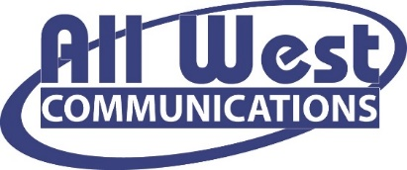

All West Communications is a drug free workplace, conducting pre-employment and random post-hire drug screening.

For more information, please visit us at www.allwest.com

